Jamie Foxx
1234 FLAT ROCK
City, State zip code

October 1, 2020

Trans Union
P.O. Box 2000
Chester, PA 19016

To Whom it may concern:

This letter is a formal complaint that you are reporting inaccurate and incomplete credit information.

account | number | amount
US AUTO FIN | 18XXXX | $10,898

I am distressed that you have included the information below in my credit profile and that you have failed to maintain reasonable procedures in your operations to assure maximum possible accuracy in the credit reports you publish. Credit reporting laws ensure that the information reported is completely accurate and correct. The following information therefore needs to be investigated.
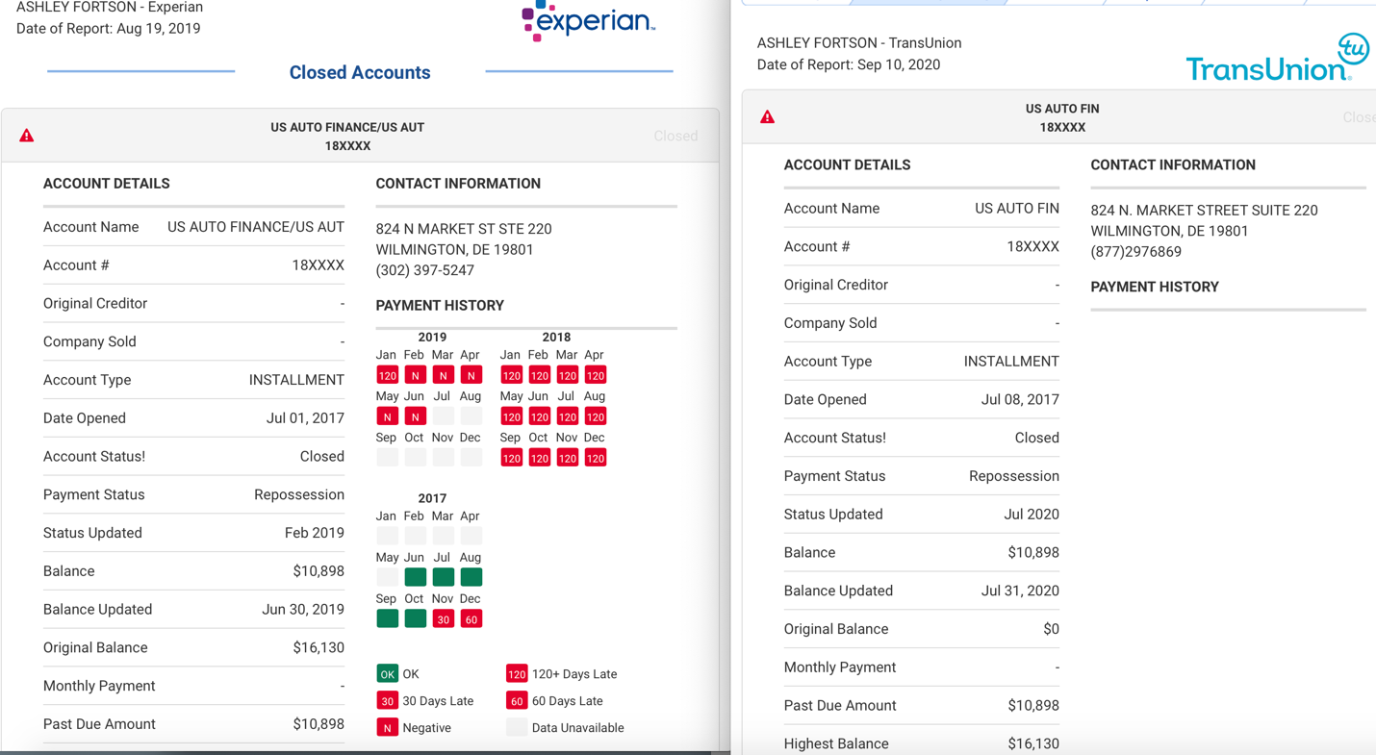

Reason #1: This account reports inaccurate and inconsistent “Date opened” across bureaus. It has been removed from both Experian and Equifax. Per FCRA, Accounts Must report accurately or they must be removed immediately. This is an inconsistency. Remove immediately.

I respectfully request to be provided proof of this alleged item, specifically the contract, note, or other instrument bearing my signature.

Failing that, the item must be deleted from the report as soon as possible. The listed item is entirely inaccurate and incomplete, and as such represents a very serious error in your reporting. Please delete this misleading information and supply a corrected credit profile to all creditors who have received a copy within the last six months, or the last two years for employment purposes.

Additionally, please provide the name, address, and telephone number of each credit grantor or other subscriber.

Under federal law, you have thirty (30) days to complete your investigation. Be advised that the description of the procedure used to determine the accuracy and completeness of the information is hereby requested as well, to be provided within fifteen (15) days of the completion of your re-investigation.

Thank you,
_________________________________________

Jamie Foxx

